We thank the reviewer for their follow-up commentary, which has helped us to strengthen the revised manuscript. Below we offer point by point responses to the comments made by the reviewer. These responses comments are in blue text. Where appropriate, we highlight specific changes to the text that we made as a result of the reviewer’s recommendation in red text.

1. The title still is ambiguous to me. Do you mean to say that the zebrafish or its microbiome is more susceptible to pathogen exposure? Also I would say M. chelonae (just be specific). Technically (language wise) every fish (or microbiome) is equally susceptible towards ‘exposure’, it is the susceptibility towards the pathogen itself that can be different.

* We appreciate the reviewer’s feedback on the title and propose the following new title: “Disentangling the link between zebrafish diet, gut microbiome succession, and *M. chelonae* infection”

2. Along the same line: In the abstract the authors phrase their research question as: ‘We further evaluated whether the 214-day-old fish microbiome compositions that result from dietary variation are differentially sensitive to infection by a common laboratory pathogen, Mycobacterium chelonae.' I guess it is again a language issue, but how can a microbiome be more sensitive to infection? Bacteriophages infect bacteria. I guess the authors mean that M.chelonae is better able to disturb one resulting microbiota compared to another?

* Here, we elected to use the ecological definition of sensitivity, which is a property of a microbial community and manifests when the community changes its composition in response to an ecological stressor, in this case *M. chelonae* infection. Conventionally, the amount a community changes serves as a quantitative measure of the community’s sensitivity to the stressor. That said, we appreciate the reviewer’s perspective and have elected to revise this passage for clarity. It now reads as: “We further evaluated how 214-day-old fish microbiome compositions respond to exposure of a common laboratory pathogen, *Mycobacterium chelonae,* and whether these responses differ as a function of diet. Our analysis finds that diet determines the manner in which the zebrafish gut microbiome responds to *M. chelonae* exposure, especially for moderate and low abundance taxa. Moreover, histopathological analysis finds that male fish fed different diets are differentially infected by *M. chelonae*.”

However, in lines 214 and further the infection of the fish themselves is discussed and there, at least in males the authors find a difference. The extraintestinal infections in Zirc fed fish are more prominent than those in Gemma and Watts-fed fish. This is a very interesting result, but now complicates the word use a bit.

To clarify, we find that exposure to the pathogen elicits diet-dependent changes to the microbiome. We also find that fish fed different diets manifest different infection rates (at least in male fish). We appreciate the reviewer’s note about how these two different observations – one with respect to the microbiome and the other with respect to host infection – can complicate interpretation of some of the language we have elected to use. To resolve this issue, we have added language throughout the manuscript that more clearly differentiates the discussion of these two points. In particular:

1. We add a statement in the abstract about how diet also impacts infection rates in male fish
2. We explicitly define the term ‘sensitivity’ with respect to its application to the microbiome results
3. Where possible, we avoid using the term ‘sensitivity’ when discussing fish infection, and instead simply note that there are different infection rates across fish fed different diets.

Examples of these changes follow:

* Line 53-54 in the introduction: “sensitivity (i.e., changes in community composition)”
* Line 154-156 in the results: “these results indicate that abundant members of the microbiome community are more sensitive (i.e., exhibit greater amounts of change) to the effects of diet, while rarer community members are sensitive to the effects of time.”
* lines 281-284 in the results: replaced ‘more sensitive to’ with ‘more impacted by’.
* Lines 326-328 of discussion: “Our study offers critical insight into how three standard zebrafish dietary formulations impacts these outcomes, finding that the zebrafish gut microbiome’s development and response to pathogen exposure is more impacted by diet.“

3. In general: Pay somewhat more attention to the text. Some sentences appear to have words missing (maybe due to track changes used before). For example: * In many instances the 4 of the 4 months is not deleted so it reads 4219 dpf (for example Line 139, line 143, Line 150 and 156 but there might be other instances)

* We appreciate the reviewer’s keen eye, but what the reviewer is likely actually seeing the 4 with a strike-through character (i.,e., ‘~~4’~~) that is difficult to differentiate from a ‘4’ character, as the track change software illustrates eliminated text with strikethrough marks. On our end, all such instances contain a strike-through character, and when we view the document with no markup, all such instances of these 4 characters are indeed eliminated. Regardless, should our manuscript be accepted, we will carefully proofread the final copy edit of the document to ensure these errors are not part of the publication.

*Line 153: Given how these metrics weigh (without -t).

* Thank you. We have removed the “t” on line 153.

*Line 164-165: rephrase sentence: Differential abundance analysis revealed taxa that were significantly associated with the effects of time and diet one of the diets (Table S2.5.1).

* We have rephrased the sentence to the following: “Differential abundance analysis revealed taxa that were significantly associated with the effects of time and diet in one of the diet groups (Table S2.5.1).”

*Line 166 delete ‘were’

* Thank you. We have removed “were” on line 166.

*Rephrase line 187-188: I do not understand the sentence. fish gut microbiomes with higher body masses?

* Thank you for this comment. To be more consistent across the text, we have replaced this statement with a reference to body condition score, which manifests statistical patterns consistent with body mass across our reported analyses.

4. I do not understand the paragraph referring to figure 5. 'In contrast, we observed the following infection outcomes for male fish with extra-intestinal infections Gemma 3/12 (25%), Watts 5/24 (20.8%), and ZIRC 18/24 (70.6%) (Figure 5B, Table 3.5.2.2S3.1.1). In male fish only, we also found a statistically significant difference in proportion of infected fish across the three diets (X2 = 11.556, df = 2, N = 53, P < 0.05; Table S3.1.2). When we conduct the same analysis with just fish sampled for microbiome analysis (Table S3.5.1.3.1), we do not observe significant effects (X2 = 4.069, df = 2, N = 44, P > 0.05; Figure 5D, Table S3.1.3.1-2), likely due to being underpowered to detect these effects.'

* We have revised this paragraph of text in total to improve clarity.

We first evaluated whether diet impacted infection outcomes, as determined by histological confirmation of infection 3.5 months following pathogen injection. We conducted a Chi-Square test to compare the infection count between fish fed the three diets. The results showed that there was a statistically significant difference in infection rates between the groups (X2 = 11.519, df = 2, N = 66, P < 0.05; Table S3.1.1). Across all three diets, all females had infected ovaries (Figure 4C), indicating there is no diet-driven difference in infection rates for female fish. As a result, we verified that the differential infection rates across diet groups was driven by male fish in a follow-up chi-square test using only male fish. This analysis confirms that infection rates are statistically different between male fish fed the ZIRC diet as compared to male fish fed either the Gemma or Watts diets (X2 = 11.556, df = 2, N = 53, P < 0.05; Figure 4D, Table S3.1.2). Because we obtained infection data from all fish reared in our study, whereas we produced microbiome data from only a subset of these fish, we also determined whether this pattern holds across the subset of male fish for which we also have microbiome data. This Chi-Square test finds no significant effect, (X2 = 4.069, df = 2, N = 44, P > 0.05; Table S3.1.3.1-2), likely due to being underpowered to detect infection rate differences on this relatively small subset of the data. Infections in males included the testis (Figure 4B), coelomic cavity, swim bladder and kidney. We observed colonization of the intestinal lumen by acid fast bacteria across all three diets in both male and female fish (Figure 4A). A linear regression did not find evidence of an association between extraintestinal infection of zebrafish and body condition score across all fish, (P > 0.05; Table S3.1.4) (P > 0.05; Table S3.1.5 & S3.1.6). Taken together, these results indicate that the diet impacts M. chelonae infection outcomes in zebrafish, but not in a way that manifests as differences in body condition score (i.e., fish size).

* Additionally, we added the following sentence to lines 373-375 and cite prior work that also found no effects of infection on fish body size (i.e., body condition score): “Additionally, we did not observe an association between infection outcomes and body condition score (i.e., fish size), which aligns with prior work that did not observe effects of M. chelonae infection on fish size in a larger cohort of zebrafish[34]”
  + **34. Kent, M.L**., Watral, V., Kirchoof, N.S., Spagnoli, S.T., Sharpton, T.S., 2016. Effects of subclinical *Mycobacterium chelonae* infections on fecundity and embryo survival in zebrafish. Zebrafish. 13(S1): S-88-S-95

Figure 5B is a picture, so it does not show the differences in percentages.

* This was a typo. “Figure 5B” should be “Figure 5D” and has been corrected.

And figure 5D shows the percentages, but different ones than mentioned above and those are then not significant?

* Thank you for noting this. In the prior version, our figure only included fish that also had microbiome samples collected from them, which is a subset of the total fish we studied in this histopathological analysis (and for which the original reported percentages were based). The figure has been updated accordingly to show the infection percentages for all male and female fish that we considered in this analysis .

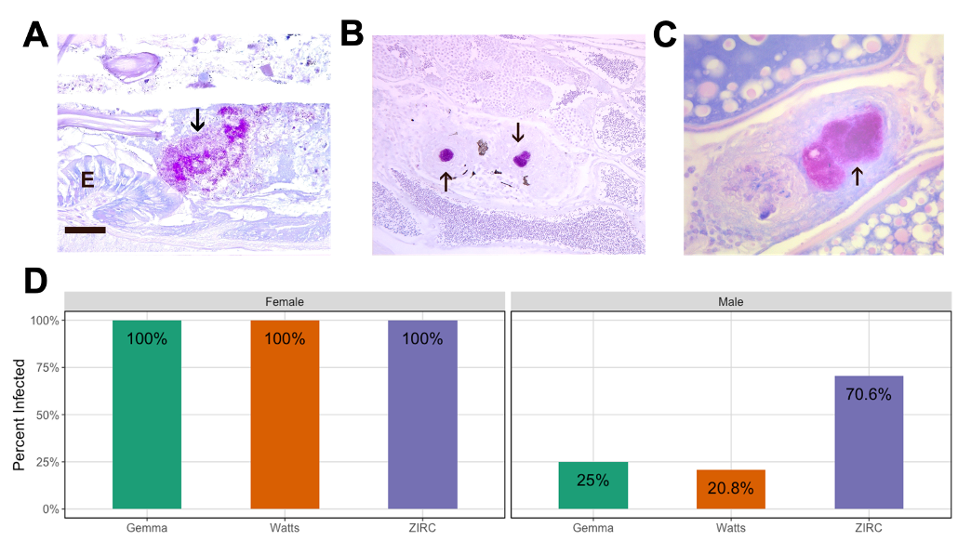

Also I do not understand ‘same analysis with just fish sampled for microbiome analysis’. Do you mean that these percentages are % of Mycobacterium chelonae in the microbiota and not the histopathological count? I need a bit more explanation and context to be able to correctly interpret these data.

* We have amended this section to be clearer: “Because we obtained infection data from all injected fish and corresponding controls, whereas we produced microbiome data from only a subset of these fish, we also determined whether this pattern holds across the subset of male fish for which we also have microbiome data. This Chi-Square test finds no significant effect, (X2 = 4.069, df = 2, N = 44, P > 0.05; Table S3.1.3.1-2), likely due to being underpowered to detect infection rate differences on this relatively small subset of the data.”

5. line 231: we did not observe significant associations between infection status and body condition score. The use of the word ‘infection’ has now become less clear to me. Infection of the fish tissue? Abundance of Mycobacteria (whether or not belonging to M chelonae?).

* We have revised this section accordingly: “A linear regression did not find evidence of an association between extraintestinal infection of zebrafish and body condition score across all fish (P > 0.05; Table S3.1.4.1), even when considering sex (P > 0.05; Table S3.1.4.2).

6. Figure 4 is partly discussed after figure 5. This also confuses the reader further. I suggest to restructure the text and help the reader through the experiments and your interpretations. It might help to have a little more concluding sentences in between and some explanation as to why certain analysis were performed. It is very hard to follow your reasoning in places. I especially got lost in the paragraph starting at line 253 and also the following paragraph ending at line 281.

* We appreciate the reviewer’s feedback, and we have restructured the results section. We’ve split up the third results subsection into two parts to separate the results that describe the effect of diet on extraintestinal infection of zebrafish from the results describing the effect of pathogen exposure (and diet) on the microbiome. Additionally, we have rearranged the figures to match this restructuring of the results section.

7. Similarly to point 6, in the discussion, sentences are very long. For example, Line 316: this sentence can be shortened and more to the point.

* We appreciate the reviewer’s feedback, and have shortened or split sentences up to improve readability and clarity.

8. Line 338: I thought that in ZIRC the Mycobacterium exposure lead to less alpha-diversity and not in the other groups while here it is stated that: gut microbiome diversification did not change…., uniquely in ZIRC. Do you mean, except (instead of uniquely) for ZIRC?

* We have changed the sentence to be clearer: “However, we found that gut microbiome diversification did not change after exposure to *M. chelonae*, exceptin ZIRC-diet fed fish relative to their unexposed controls.”